
МИНИСТЕРСТВО НАУКИ И ВЫСШЕГО ОБРАЗОВАНИЯ РОССИЙСКОЙ ФЕДЕРАЦИИ
федеральное государственное бюджетное образовательное учреждение высшего образования
«УЛЬЯНОВСКИЙ ГОСУДАРСТВЕННЫЙ ТЕХНИЧЕСКИЙ УНИВЕРСИТЕТ»
Факультет информационных систем и технологий
Кафедра «Информационные системы»
Дисциплина «Интернет-программирование»
Лабораторная работа №4
REST-контроллеры
Выполнил:
студентка гр. ПИбд-21
Сорокни П.В.
Проверил:
доцент кафедры
Филиппов А.А.
Ульяновск, 2023

Задание:
1.Для каждого класса с бизнес-логикой из предыдущей работы разработать
свой REST-контроллер.
2.Работу с базой данных необходимо осуществлять через DAO
(JpaRepository).
3.Получение сущностей необходимо реализовать через Get метод
контроллера. Идентификатор сущности следует передавать через PathVariable.
4.Создание сущностей необходимо реализовать через Post метод контроллера.
Данные следует передавать через тело запроса (RequestBody) с помощью DTO.
5.Обновление сущностей необходимо реализовать через Put метод
контроллера. Идентификатор сущности следует передавать через PathVariable, а
содержимое сущности через тело запроса с помощью DTO.
6.Удаление сущностей необходимо реализовать через Delete метод
контроллера. Идентификатор сущности следует передавать через PathVariable.
7.Реализовать клиентскую часть приложения с помощью Vue.js или React.
Рекомендуется использовать приложение из предыдущего семестра.
Решение:
Серверная часть
- REST-контроллеры
package ru.ulstu.is.sbapp.Comment.controller;
import org.springframework.web.bind.annotation.*;
import ru.ulstu.is.sbapp.Comment.service.CommentService;
import java.util.List;
@RestController
@RequestMapping("/comment")
public class CommentController {
private final CommentService commentService;
public CommentController(CommentService commentService) {
this.commentService = commentService;
}
@GetMapping("/{id}")
public CommentDto getComment(@PathVariable Long id) {
return new CommentDto(commentService.findComment(id));
}
@GetMapping
public List<CommentDto> getComments() {
return commentService.findAllComments().stream()
.map(CommentDto::new)
.toList();
}
@PostMapping
public CommentDto createComment(@RequestParam("Text") String Text){
return new CommentDto(commentService.addComment(Text));
}
@PutMapping("/{id}")
public CommentDto updateComment(@PathVariable Long id,
@RequestParam("Text") String Text){
return new CommentDto(commentService.updateComment(id,Text));
}
@DeleteMapping("/{id}")
public CommentDto deleteComment(@PathVariable Long id) {
return new CommentDto(commentService.deleteComment(id));
}
}

package ru.ulstu.is.sbapp.Post.controller;
import jakarta.validation.Valid;
import org.springframework.web.bind.annotation.*;
import ru.ulstu.is.sbapp.Comment.controller.CommentDto;
import ru.ulstu.is.sbapp.Post.model.Post;
import ru.ulstu.is.sbapp.Post.service.PostService;
import ru.ulstu.is.sbapp.User.controller.UserDto;
import ru.ulstu.is.sbapp.User.service.UserService;
import java.util.List;
@RestController
@RequestMapping("/post")
public class PostController {
private final PostService postService;
public PostController(PostService postService) {
this.postService = postService;
}
@GetMapping("/{id}")
public PostDto getPost(@PathVariable Long id) {
return new PostDto(postService.findPost(id));
}
@GetMapping
public List<PostDto> getPosts() {
return postService.findAllPosts().stream()
.map(PostDto::new)
.toList();
}
@GetMapping("/{id}/comments")
public List<CommentDto> getComments(@PathVariable Long id) {
return postService.GetPostComments(id).stream()
.map(CommentDto::new)
.toList();
}
@PostMapping
public PostDto createPost(@RequestBody @Valid PostDto postDto){
return new PostDto(postService.addPost(postDto));
}
@PutMapping("/{id}")
public PostDto updatePost(@PathVariable Long id,
@RequestBody @Valid PostDto postDto){
return new PostDto(postService.updatePost(id,postDto));
}
@PostMapping("/{id}/Comment/{userId}")
public void addComment(@PathVariable Long id,
@PathVariable Long userId,
@RequestParam("Text") String Text) {
postService.addCommentToPost(id, userId,Text);
}
@DeleteMapping("/{id}/Comment/{commentId}")
public void removeComment(@PathVariable Long id,
@PathVariable Long commentId)
{
postService.removeCommentFromPost(id,commentId);
}
@DeleteMapping("/{id}")
public void deletePost(@PathVariable Long id) {
postService.deletePost(id);
}
@DeleteMapping
public void deleteall()
{
postService.deleteAllPosts();
}
@GetMapping("/filteredposts")
public List<PostDto> getPostsAndComments(@RequestParam("Text") String Text){
return postService.getPostsAndComments(Text).stream()
.map(PostDto::new)
.toList();
}
}

package ru.ulstu.is.sbapp.User.controller;
import jakarta.validation.Valid;
import org.springframework.web.bind.annotation.*;
import ru.ulstu.is.sbapp.Post.controller.PostDto;
import ru.ulstu.is.sbapp.Post.model.Post;
import ru.ulstu.is.sbapp.User.service.UserService;
import java.util.List;
@RestController
@RequestMapping("/user")
public class UserController {
private final UserService userService;
public UserController(UserService userService) {
this.userService = userService;
}
@GetMapping("/{id}")
public UserDto getUser(@PathVariable Long id) {
return new UserDto(userService.findUser(id));
}
@GetMapping
public List<UserDto> getUsers() {
return userService.findAllUsers().stream()
.map(UserDto::new)
.toList();
}
@GetMapping("/{id}/posts")
public List<PostDto> getPosts(@PathVariable Long id) {
return userService.GetUserPosts(id).stream()
.map(PostDto::new)
.toList();
}
@PostMapping
public UserDto createUser(@RequestParam("firstName") String firstName,
@RequestParam("lastName") String lastname,
@RequestParam("email") String email) {
return new UserDto(userService.addUser(firstName, lastname,email));
}
@PutMapping("/{id}")
public UserDto updateClient(@PathVariable Long id,
@RequestParam("firstName") String firstName,
@RequestParam("lastName") String lastname,
@RequestParam("email") String email){
return new UserDto(userService.updateUser(id, firstName, lastname,email));
}
@PostMapping("/{id}/Post")
public void addPost(@PathVariable Long id,
@RequestBody @Valid PostDto postDto) {
userService.addNewPost(id, postDto);
}
@DeleteMapping("/{id}/Post/{postId}")
public void removePost(@PathVariable Long id,
@PathVariable Long postId)
{
userService.deletePost(id,postId);
}
@DeleteMapping("/{id}")
public void deleteUser(@PathVariable Long id) {
userService.deleteUser(id);
}
}

- DAO-слой
package ru.ulstu.is.sbapp.Comment.repository;
import org.springframework.data.jpa.repository.JpaRepository;
import ru.ulstu.is.sbapp.Comment.model.Comment;
public interface CommentRepository extends JpaRepository<Comment, Long> {
}

package ru.ulstu.is.sbapp.Post.repository;
import org.springframework.data.jpa.repository.JpaRepository;
import org.springframework.data.jpa.repository.Modifying;
import org.springframework.data.jpa.repository.Query;
import ru.ulstu.is.sbapp.Comment.model.Comment;
import ru.ulstu.is.sbapp.Post.model.Post;
import java.util.List;
import java.util.Optional;
public interface PostRepository extends JpaRepository<Post, Long>{
@Query("Select c from Comment c where post.id = :id")
List<Comment> getPostComments(Long id);
@Query("Select p from Post p join p.comments c Where p.content Like concat('%', :text, '%') or c.Text Like concat('%', :text, '%')")
List<Post> getPostsAndComments(String text);
}

package ru.ulstu.is.sbapp.User.repository;
import org.springframework.data.jpa.repository.JpaRepository;
import org.springframework.data.jpa.repository.Modifying;
import org.springframework.data.jpa.repository.Query;
import ru.ulstu.is.sbapp.Post.model.Post;
import ru.ulstu.is.sbapp.User.model.User;
import java.util.List;
public interface UserRepository extends JpaRepository<User, Long> {
@Query("Select p from Post p where user.id = :id")
List<Post> getUsersPosts(Long id);
}
- DTO
package ru.ulstu.is.sbapp.Comment.controller;
import ru.ulstu.is.sbapp.Comment.model.Comment;
import ru.ulstu.is.sbapp.Post.model.Post;
import ru.ulstu.is.sbapp.User.model.User;
public class CommentDto {
private Long id;
private String Text;
private String userName;
public CommentDto(){}
public CommentDto(Comment comment)
{
this.id= comment.getId();
this.Text=comment.getText();
this.userName=comment.getUser().getFirstName() + " " + comment.getUser().getLastName();
}
public Long getId()
{
return id;
}
public String getText() {return Text;}
public String getUser()
{
return userName;
}
}

package ru.ulstu.is.sbapp.Post.controller;
import ru.ulstu.is.sbapp.Comment.controller.CommentDto;
import ru.ulstu.is.sbapp.Comment.model.Comment;
import ru.ulstu.is.sbapp.Post.model.Post;
import ru.ulstu.is.sbapp.User.model.User;
import java.nio.charset.StandardCharsets;
import java.util.ArrayList;
import java.util.List;
public class PostDto {
private Long id;
private String heading;
private String content;
private List<CommentDto> comments = new ArrayList<>();
private String image;
public PostDto(){}
public PostDto(Post post) {
this.id = post.getId();
this.heading = post.getHeading();
this.content = post.getContent();
this.image = new String(post.getImage(), StandardCharsets.UTF_8);
if (post.getComments() != null) {
comments = post.getComments().stream()
.map(CommentDto::new).toList();
}
}
public Long getId()
{
return id;
}
public String getHeading()
{
return heading;
}
public String getContent()
{
return content;
}
public List<CommentDto> getComments()
{
return comments;
}
public String getImage() {
return image;
}
}

package ru.ulstu.is.sbapp.User.controller;
import ru.ulstu.is.sbapp.Comment.model.Comment;
import ru.ulstu.is.sbapp.Post.model.Post;
import ru.ulstu.is.sbapp.User.model.User;
import java.util.ArrayList;
import java.util.List;
public class UserDto {
private Long id;
private String firstName;
private String lastName;
private String email;
private List<Post> posts = new ArrayList<>();
private List<Comment> comments = new ArrayList<>();
public UserDto(){}
public UserDto(User user) {
this.id=user.getId();
this.firstName = user.getFirstName();
this.lastName = user.getLastName();
this.email= user.getEmail();
}
public Long getId() {
return id;
}
public String getFirstName() {
return firstName;
}
public String getLastName() {
return lastName;
}
public List<Post> getPosts()
{
return posts;
}
public List<Comment> getComments()
{
return comments;
}
public String getEmail()
{
return email;
}
}

Клиентская часть
Файл App.jsx Данный код представляет React-компонент App, который определяет маршрутизацию и отображение различных компонентов на основе пути URL.

import { useRoutes, Outlet, BrowserRouter } from 'react-router-dom';
import Header from './components/common/Header';
import Catalogs from './components/catalogs/MainPage';
import CatalogGroups from './components/catalogs/Autorize';
import CatalogStudents from './components/catalogs/News';
import Post from './components/catalogs/Post';
import Reports from './components/catalogs/RezhimRaboty';
import ReportGroupStudents from './components/catalogs/Raspisanie';
import Footer from './components/common/Footer';

function Router(props) {
return useRoutes(props.rootRoute);
}

export default function App() {
const routes = [
{ index: true, element: <Catalogs /> },
{ path: 'Main_page', element: <Catalogs />, label: 'Главная' },
{ path: 'News', element: <CatalogStudents/>, label:'Новости' },
{ path: 'Autorize', element: <CatalogGroups />, label:'Авторизация'},
{ path: 'RezhimRaboty', element: <Reports />, label: 'Режим работы' },
{ path: 'Raspisanie', element: <ReportGroupStudents />,label:'Расписание' },
{ path: 'Post', element: <Post/>}
];
const links = routes.filter(route => route.hasOwnProperty('label'));
const rootRoute = [
{ path: '/', element: render(links), children: routes }
];

function render(links) {
return (
<div className='body_app'>
<Header links={links} />
<div className="d-flex text-white bg-info bg-gradient fw-bold">
<Outlet />
</div>
<Footer links={links}/>
</div>
);
}

return (
<BrowserRouter>
<Router rootRoute={ rootRoute } />
</BrowserRouter>
);
}

Файл Catalog.jsx. Данный код представляет собой React-компонент, который является шаблоном для отображения списка сущностей в виде карточек.
import { useState, useEffect } from "react";
import Toolbar from "../common/Toolbar";
import Table from "../common/Card";
import Modal from "../common/Modal";

export default function Catalog(props) {
const [items, setItems] = useState([]);
const [modalHeader, setModalHeader] = useState('');
const [modalConfirm, setModalConfirm] = useState('');
const [modalVisible, setModalVisible] = useState(false);
const [isEdit, setEdit] = useState(false);
const [userId,setUserId] = useState(0);
const [value,setvalue]=useState('');
useEffect(() => {
loadItems();
}, []);

useEffect(()=>
{
loadItems();
},[userId])

useEffect(()=>
{
loadItems2();
},[value])
const setUserIDd = async function(id)
{
setUserId(id);
}
const loadItems = async function() {
const requestUrl = `http://localhost:8080/user/${userId}/posts`;
const response = await fetch(requestUrl);
const posts = await response.json();
setItems(posts);
}

const loadItems2 = async function() {
const requestUrl = `http://localhost:8080/post/filteredposts?Text=${value}`;
const response = await fetch(requestUrl);
const posts = await response.json();
console.log(posts);
setItems(posts);
}

const saveItem = async function() {
if (!isEdit) {
const requestUrl = `http://localhost:8080/user/${userId}/Post`;
const temppost=JSON.stringify(props.data)
const requestParams = {
method: "POST",
headers: {
"Content-Type": "application/json",
},
body: temppost,
};
await fetch(requestUrl,requestParams).then(() => loadItems());

} else {
const requestUrl = "http://localhost:8080/post/"+props.data.id;
const temppost=JSON.stringify(props.data)
const requestParams = {
method: "PUT",
headers: {
"Content-Type": "application/json",
},
body: temppost,
};
await fetch(requestUrl,requestParams).then(() => loadItems());
}
}

function handleAdd() {
setEdit(false);
setModalHeader('Добавление элемента');
setModalConfirm('Добавить');
setModalVisible(true);
props.onAdd();
}

const edit = async function(editedId) {
const requestUrl = "http://localhost:8080/post/"+editedId;
const requestParams = {
mode: 'cors'
}
await fetch(requestUrl,requestParams)
.then(data => {
setEdit(true);
setModalHeader('Редактирование элемента');
setModalConfirm('Сохранить');
setModalVisible(true);
//props.onEdit(data);
return data.json();
}).then(data =>{
props.onEdit(data);
});
}

const handleRemove = async function(id) {
if (confirm('Удалить выбранные элементы?')) {
const requestUrl = `http://localhost:8080/user/${userId}/Post/`+id;
const requestParams = {
method: "DELETE",
headers: {
"Content-Type": "application/json",
},
};
await fetch(requestUrl,requestParams).then(()=>loadItems());
}
}

function handleModalHide() {
setModalVisible(false);
}

function handleModalDone() {
saveItem();
}

return (
<>
<div className="mx-3 my-2"><input type="text" id="search" className="form-control" required onChange={(event)=> setvalue(event.target.value)}/></div>
<Toolbar
onAdd={handleAdd}
getUser={setUserIDd}
/>
<Table
headers={props.headers}
items={items}
value={value}
userId={userId}
selectable={true}
onEdit={edit}
onRemove={handleRemove}/>
<Modal
header={modalHeader}
confirm={modalConfirm}
visible={modalVisible}
onHide={handleModalHide}
onDone={handleModalDone}>
{props.children}
</Modal>
</>
);
}

import React from "react";
import { useState } from 'react';
import {useEffect} from 'react';
import UserDto from '../../models/UserDto';
export default function CatalogGroups(props) {
const formRef = React.createRef();
const [output, setOutput] = useState([]);
const FirstInput = document.getElementById("validationCustom01");
const LastInput = document.getElementById("validationCustom02");
const emailInput = document.getElementById("validationCustomMail");
const getAll = async function () {
const requestUrl = "http://localhost:8080/user";
const response = await fetch(requestUrl);
const users = await response.json();
setOutput(users);
}
useEffect(() => {
getAll();
}, []);
const remove = async function(id){
const requestParams = {
method: "DELETE",
headers:{
"Content-Type":"application/json",
}
};
const requestUrl = "http://localhost:8080" + "/user/" + id;
const response=await fetch(requestUrl,requestParams);
return await response.json;
};
const create = async function (firstName, lastName,Email) {
const requestParams = {
method: "POST",
headers: {
"Content-Type": "application/json",
}
};
const response = await fetch("http://localhost:8080" + `/user?firstName=${firstName}&lastName=${lastName}&email=${Email}`, requestParams);
return await response.json();
}
const refresh = async function(id,firstName, lastName,Email)
{
const requestParams={
method:"PUT",
headers:{
"Content-Type":"application/json",
}
};
const response=await fetch(`http://localhost:8080/user/${id}?firstName=${firstName}&lastName=${lastName}&email=${Email}`,requestParams);
return await response.json();
}
const add_but = function(event)
{
event.preventDefault();
create(FirstInput.value, LastInput.value,emailInput.value).then((result) => {
getAll();
FirstInput.value = "";
LastInput.value = "";
emailInput.value="";
alert(`User[id=${result.id}, firstName=${result.firstName}, lastName=${result.lastName},email=${result.email}]`);
});
}
const edit_btn = function(id,event)
{
console.log("Обновление")
refresh(id,FirstInput.value, LastInput.value,emailInput.value).then((result)=>{
getAll();
FirstInput.value = "";
LastInput.value = "";
emailInput.value="";
});
}
const rem_but = function(id,event)
{
console.log("Удаление")
remove(id).then((result)=>{
getAll();
});
}

return (
<div className="p-2">
<form className="row g-3 needs-validation">
<div className="col-md-4">
<label className="form-label" htmlFor="validationCustom01">Имя</label>
<input className="form-control" id="validationCustom01" type="text" defaultValue="" required/>
<div className="valid-feedback">Отлично!</div>
<div className="invalid-feedback">Введите имя!</div>
</div>
<div className="col-md-4">
<label className="form-label" htmlFor="validationCustom02">Фамилия</label>
<input className="form-control" id="validationCustom02" type="text" defaultValue="" required/>
<div className="valid-feedback">Отлично! </div>
<div className="invalid-feedback">Введите Фамилию!</div>
</div>
<div className="col-md-4">
<label className="form-label" htmlFor="validationCustomMail">Почта</label>
<div className="input-group has-validation">
<input className="form-control" id="validationCustomMail" type="email" aria-describedby="inputGroupPrepend" required/>
<div className="valid-feedback">Отлично!</div>
<div className="invalid-feedback">Введите почту!</div>
</div>
</div>
<div className="col-12">
<div className="form=check">
<input className="form-check-input" id="invalidCheck" type="checkbox" defaultValue="" required/>
<label className="form-check-label" htmlFor="invalidCheck">Согласие на обработку персональных данных</label>
<div className="valid-feedback">Отлично!</div>
<div className="invalid-feedback">Введите пароль!</div>
</div>
</div>
<div className="col-12 d-flex">
<div className="d-grid col-sm-4 mx-auto">
<button type="button" id="add_btn" className="btn btn-outline-light btn-lg float-end" onClick={add_but}>Add</button>
</div>
</div>
</form>
<div className="row table-responsive mx-2">
<table className="table mt-3">
<thead>
<tr>
<th scope="col">#</th>
<th scope="col">Last Name</th>
<th scope="col">First Name</th>
<th scope="col">Email</th>
<th scope="col"></th>
<th scope="col"></th>
</tr>
</thead>
<tbody id="tbody">
{output.map((user) => (
<tr key={user.id}>
<th scope="row">{user.id}</th>
<td>{user.firstName}</td>
<td>{user.lastName}</td>
<td>{user.email}</td>
<td><button type="button" className="btn btn-outline-light text-center mx-2" onClick={(e) => edit_btn(user.id, e)}><i className="fa-sharp fa-solid fa-pen"></i></button></td>
<td><button type="button" className="btn btn-outline-light text-center mx-2" onClick={(e) => rem_but(user.id, e)}><i className="fa-sharp fa-solid fa-trash"></i></button></td>
</tr>
))}
</tbody>
</table>
</div>
</div>
);
}

import { useState, useEffect } from 'react';
import Catalog from './Catalog';
import New from '../../models/NewDto';

export default function News(props) {
const url = 'post/';
const transformer = (data) => new New(data);
const catalogStudHeaders = [
{ name: 'image', label: 'Картинка' },
{ name: 'heading', label: 'Заголовок' },
{ name: 'content', label: 'Новости' },
];

const [data, setData] = useState(new New());
const fileReader=new FileReader();
fileReader.onloadend=()=>{
const tempval=fileReader.result;
setData({ ...data, ['image']: tempval})
}
const handleOnChange=(event)=>{
event.preventDefault();
const file=event.target.files[0];
fileReader.readAsDataURL(file);
};

function handleOnAdd() {
setData(new New());
}

function handleOnEdit(data) {
setData(new New(data));
}
function handleFormChange(event) {
setData({ ...data, [event.target.id]: event.target.value })
}

return (
<Catalog
headers={catalogStudHeaders}
url={url}
transformer={transformer}
data={data}
onAdd={handleOnAdd}
onEdit={handleOnEdit}>
<div className="mb-3 text-black">
<label htmlFor="image" className="form-label">Изображение</label>
<input type="file" id="image" className="form-control" required onChange={handleOnChange}/>
</div>
<div className="mb-3">
<label htmlFor="heading" className="form-label text-black">Заголовок</label>
<input type="text" id="heading" className="form-control" required
value={data.heading} onChange={handleFormChange}/>
</div>
<div className="mb-3">
<label htmlFor="content" className="form-label text-black">Содержание</label>
<input type="text" id="content" className="form-control" required
value={data.content} onChange={handleFormChange}/>
</div>
</Catalog>
);
}

import React from "react";
import { useState } from 'react';
import {useEffect} from 'react';
import New from '../../models/NewDto';
import TableComment from "../common/TableComment";

export default function Post(props) {
useEffect(() => {
getAll();
}, []);
const [output, setOutput] = useState([]);
const [userId,setUserId] = useState();
const commentInput = document.getElementById("commentText");

const getAll = async function () {
const queryString=window.location.search;
const urlParams=new URLSearchParams(queryString);
const id=urlParams.get('id');
getCurrentPost(id).then(curPost => setad(curPost));
getComments(id)

const requestUrl = "http://localhost:8080/user";
const response = await fetch(requestUrl);
const users = await response.json();
setOutput(users);
}

const refresh = async function(id,text)
{
const requestParams={
method:"PUT",
headers:{
"Content-Type":"application/json",
}
};
const response=await fetch(`http://localhost:8080/comment/${id}?Text=${text}`,requestParams);
return await response.json();
}

const create = async function (text, id) {
const requestParams = {
method: "POST",
headers: {
"Content-Type": "application/json",
}
};
const response = await fetch(`http://localhost:8080/post/${ad.id}/Comment/${id}?Text=${text}`,requestParams);
}

const getCurrentPost = async function (id) {
const requestUrl = "http://localhost:8080/post/"+id;
const response = await fetch(requestUrl);
const product = await response.json();
return product;
}

const remove = async function(id){
const requestParams = {
method: "DELETE",
headers:{
"Content-Type":"application/json",
}
};
const requestUrl = `http://localhost:8080/post/${ad.id}/Comment/${id}`;
const response=await fetch(requestUrl,requestParams);
return await response.json;
};

function getuser(){
var selectBox = document.getElementById("selectBox");
var selectedValue = selectBox.options[selectBox.selectedIndex].value;
setUserId(selectedValue);
}

const getComments = async function(id)
{
const requesturl = "http://localhost:8080/post/"+id+"/comments"
const response = await fetch(requesturl);
const comments = await response.json();
setComments(comments);
}
const [ad, setad] = useState([]);
const [comments,setComments] = useState([]);

const rem_but = function(id,event)
{
remove(id).then((result)=>{
getAll();
});
}

const add_but = function(event)
{
event.preventDefault();
create(commentInput.value, userId).then((result) => {
getAll();
commentInput.value = "";
alert(`Comment[id=${result.id}, text=${result.firstName}]`);
});
}

const edit_btn = function(id,event)
{
console.log("Обновление")
refresh(id, commentInput.value).then((result)=>{
getAll();
commentInput.value = "";
});
}
return(
<div>
<div className="da d-flex my-2">
<div><img className="imga img-fluid float-start mx-2" style={{width: "500px" ,height: "300px" }} src={ad.image}/></div>
<div className="container-fluid my-2 mx-1">
<h1>{ad.heading}</h1>
<p>{ad.content}</p>
</div>
</div>
<div className="d-flex mx-2">
<select id="selectBox" onChange={getuser}>
<option disabled value="">Выбор...</option>
{
output.map((client) => (
<option className='text-black' key={client.id} value={client.id}>{client.firstName}</option>
))}
</select>
<input className="form-control" id="commentText" type="text" defaultValue="" required/>
<button type="button" className="btn btn-primary" onClick={(e)=>add_but(e)}>
+
</button>
</div>
<div className="row table-responsive mx-2">
<TableComment
comments={comments}
onRemove={rem_but}
onEdit={edit_btn}
/>
</div>
</div>

);

}

import { useEffect, useState } from 'react';
import ModalEdit from './ModalComment';
import TablePostAndComment from './TablePostAndComment';
export default function Card(props) {

function edit(id) {
props.onEdit(id);
}

function remove(id) {
props.onRemove(id);
}
useEffect(() => {
getAll();
}, []);

const [clients, setClientst] = useState([]);
const getAll = async function () {
const requestUrl = "http://localhost:8080/user";
const response = await fetch(requestUrl);
const users = await response.json();
setClientst(users);
}
const [modalTable, setModalTable] = useState(false);
const [currEditItem, setCurrEditItem] = useState(0);
const [text, setText] = useState('');
function handleEdit(id) {
console.info("Start edit script");
setCurrEditItem(id);
setModalTable(true)
console.info('End edit script');
};
const handleSubmitEdit = async (e, id) => {
console.info('Start synchronize edit');
e.preventDefault(); // страница перестает перезагружаться
const requestUrl = `http://localhost:8080/post/${id}/Comment/${props.userId}?Text=${text}`;
const requestParams = {
method: "POST",
headers: {
"Content-Type": "application/json",
},
};
await fetch(requestUrl,requestParams);
setText('');
setModalTable(false);
};

return (
<div className="container-fluid mt-3">
{
props.items.map((item, index) =>
<div key={item.id}
className="card border-dark mb-3 d-flex flex-row text-black justify-content-between">
<div className=''>
<img className="col" style={{width: "300px" ,height: "200px" }} src={item.image}/>
</div>
<div className='d-flex flex-grow-1 flex-column'>
<div className='flex-grow-1 mx-2'>
{
props.headers.map(header =>
header.name == "image" ? null :
<div className="" key={item.id + header.name}>{item[header.name]}</div>
)
}
</div>
<div className="d-flex flex-row justify-content-end ">
<button type="button" className="btn btn-outline-primary text-center mx-2" data-bs-toggle="modal" data-bs-target="#redact" onClick={(e) => edit(item.id, e)}>
<i className="fa-sharp fa-solid fa-pen"></i>
</button>
<button href="#"
className="btn btn-outline-primary mx-3"
onClick={(e) => remove(item.id, e)}><i className="fa-sharp fa-solid fa-trash"></i></button>
<a href={`/Post?id=${item.id}`} className='btn btn-outline-primary mx-2'><i className="fa-solid fa-envelopes-bulk"></i></a>
</div>
<TablePostAndComment
comments={item.comments}
value={props.value}
/>
</div>
</div>
)
}
<ModalEdit visible={modalTable} setVisible={setModalTable}>
<form className="g-3 fs-4 description fw-bold container" id="frm-items-edit" onSubmit={(e) => handleSubmitEdit(e, currEditItem)}>
<div className="row">
<label className="form-label" htmlFor="priceEdit">Комментарий</label>
<input value={text} onChange={e => setText(e.target.value)} className="form-control" name='priceEdit' id="priceEdit" type="text" placeholder="Введите содержимое комментария" required />
</div>
<div className="text-center mt-3">
<button className="btn btn-primary mx-1" type="submit" id="buttonSaveChanges">Сохранить изменения</button>
<button className="btn btn-secondary mx-1" type="button" data-bs-dismiss="modal" onClick={() => setModalTable(false)}>Отмена</button>
</div>
</form>
</ModalEdit>
</div>
);
}

export default function TableComment(props) {
function edit(id,e) {
props.onEdit(id);
}

function remove(id,e) {
props.onRemove(id,e);
}

return(
<table className="table mt-3">
<thead>
<tr>
<th scope="col">#</th>
<th scope="col">Text</th>
<th scope="col"></th>
<th scope="col"></th>
</tr>
</thead>
<tbody id="tbody">
{props.comments.map((comment) => (
<tr key={comment.id}>
{console.log(comment.user)}
<th scope="row">{comment.user}</th>
<td>{comment.text}</td>
<td><button type="button" className="btn btn-outline-light text-center mx-2" onClick={(e) => edit(comment.id, e)}><i className="fa-sharp fa-solid fa-pen"></i></button></td>
<td><button type="button" className="btn btn-outline-light text-center mx-2" onClick={(e) => remove(comment.id, e)}><i className="fa-sharp fa-solid fa-trash"></i></button></td>
</tr>
))}
</tbody>
</table>
);
}

export default function TablePostAndComment(props) {
const filteredads=props.comments.filter(ads=>{
return ads.text.includes(props.value);
})
return(
<table className="table mt-3">
<thead>
<tr>
<th scope="col"></th>
<th scope="col"></th>
<th scope="col"></th>
<th scope="col"></th>
</tr>
</thead>
<tbody id="tbody">
{filteredads.map((comment) => (
<tr key={comment.id}>
{console.log(comment.user)}
<th scope="row">{comment.user}</th>
<td>{comment.text}</td>
</tr>
))}
</tbody>
</table>
);
}

Скриншоты работы программы
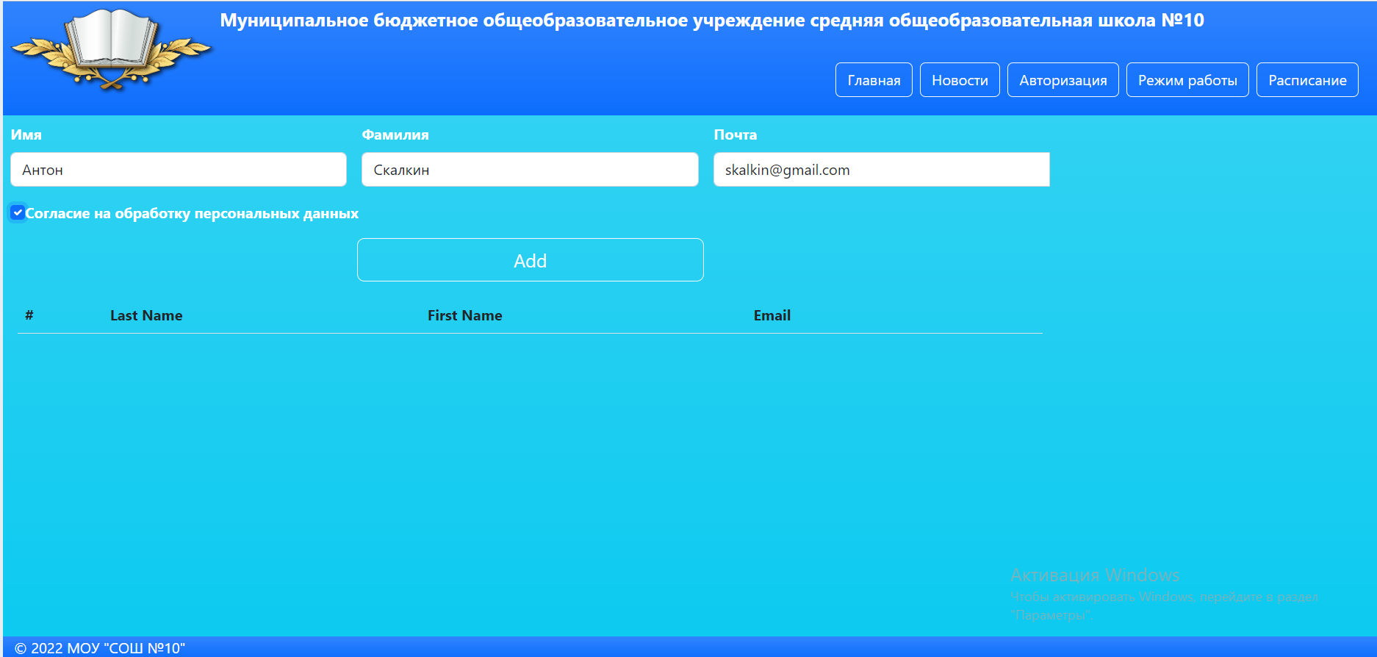
Главная страница «Пользователей»
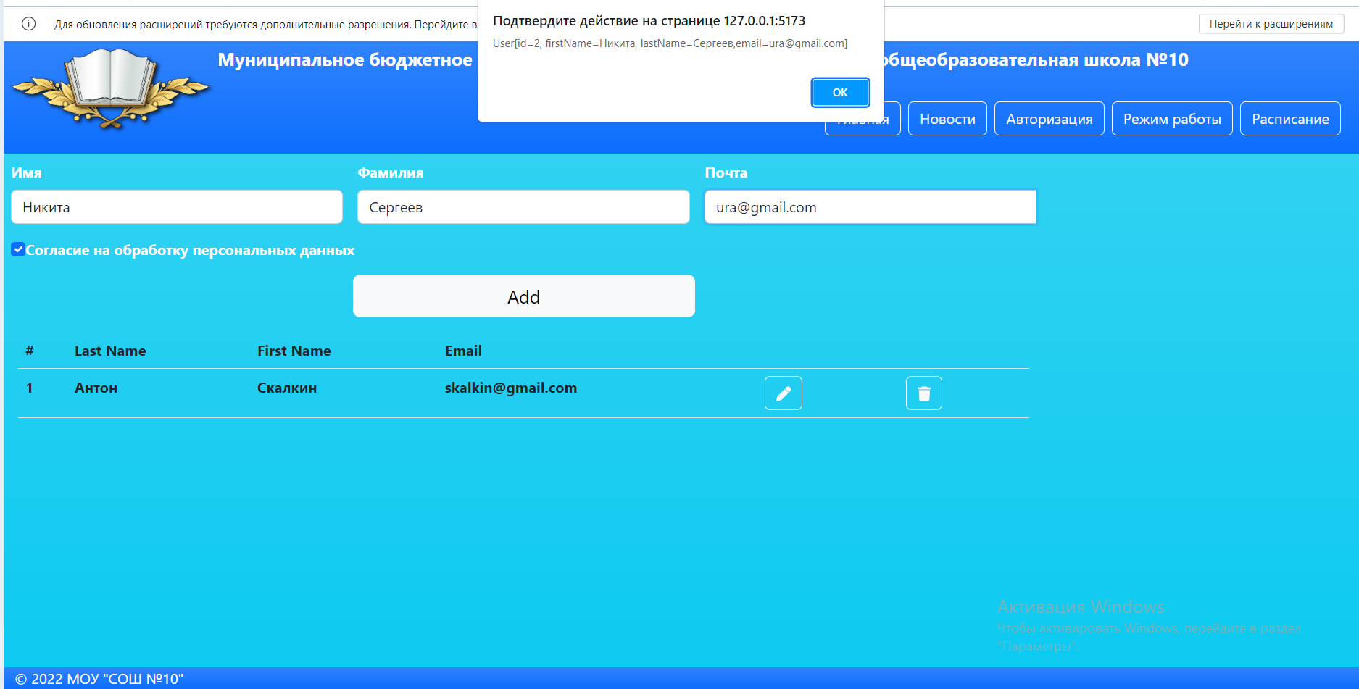
Главная страница «Пользователей» - добавление пользователя

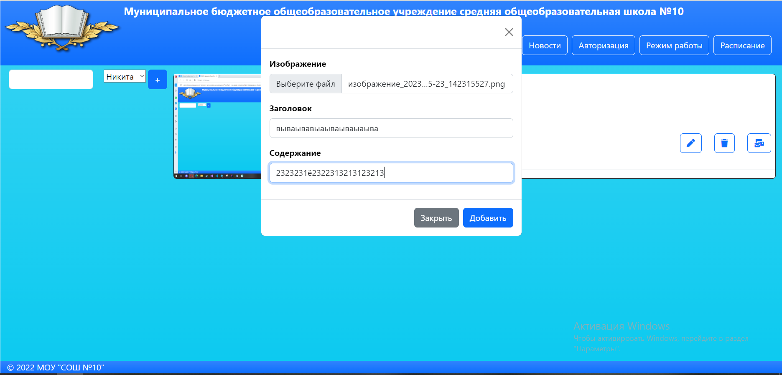
Страница с постами– создание поста

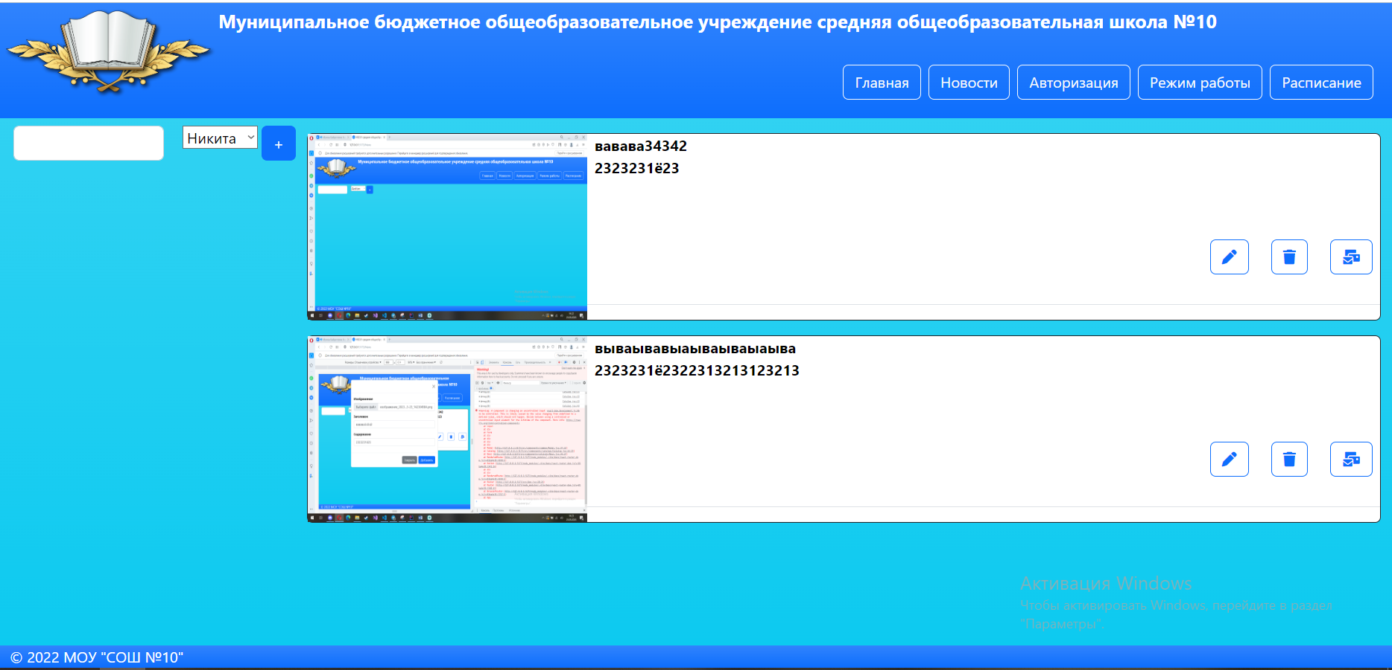
Страница с постами

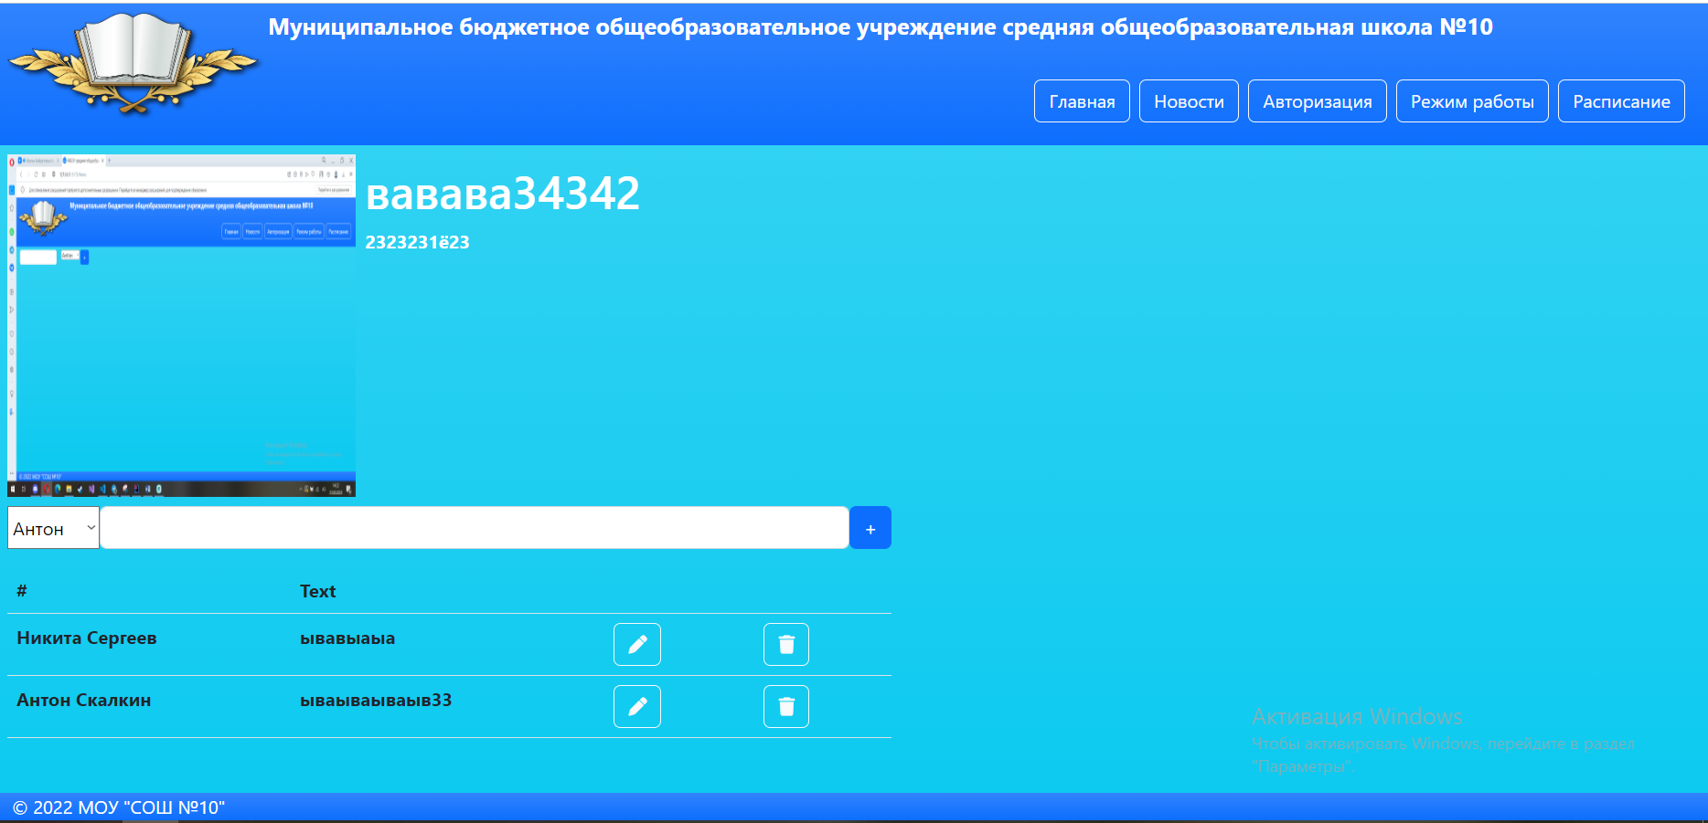
Страница с отдельным постом (страница комментариев)

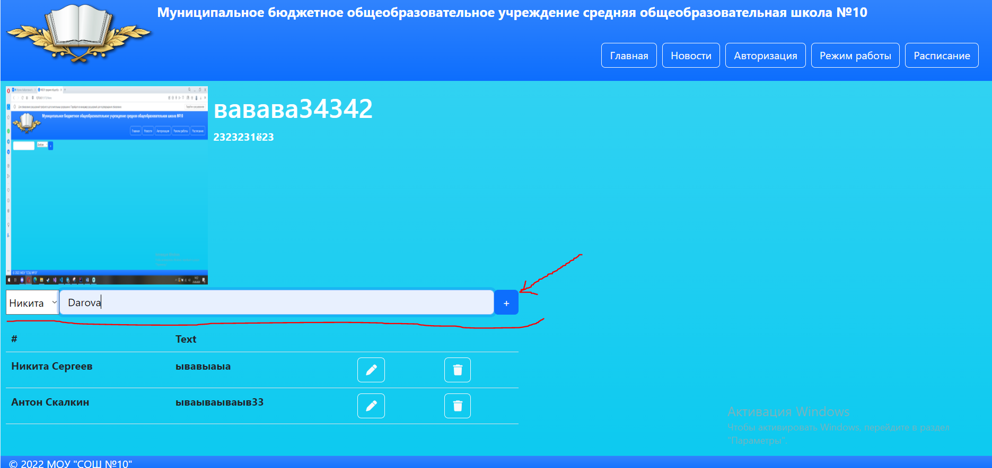
Страница с отдельным посто (страница комментариев) – создание коммента

